1 Review the request
  - A three step product walkthrough using sample data
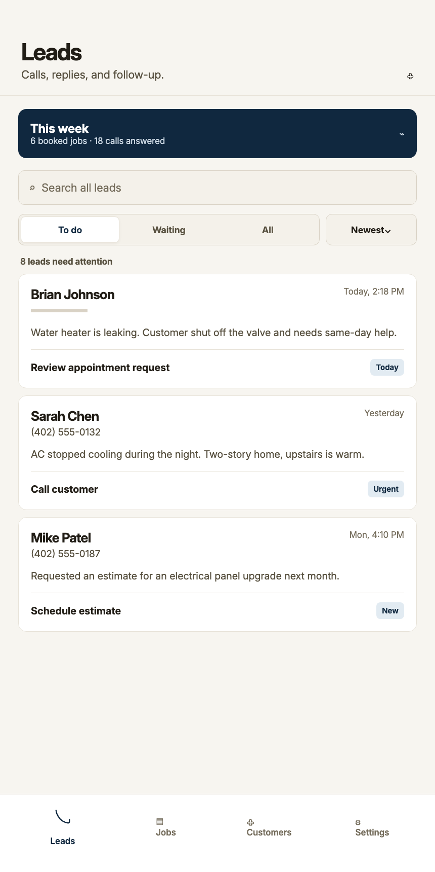
Sample Leads screen. Names and requests are demonstration data.

See what needs attention
Open Leads to review incoming requests and follow-up work. Select a lead to see the details before choosing the next action.
A useful question for your demo: Where would our missed-call requests appear, and who on our team would review them?

2 Read the call details
  - The context for a useful next step
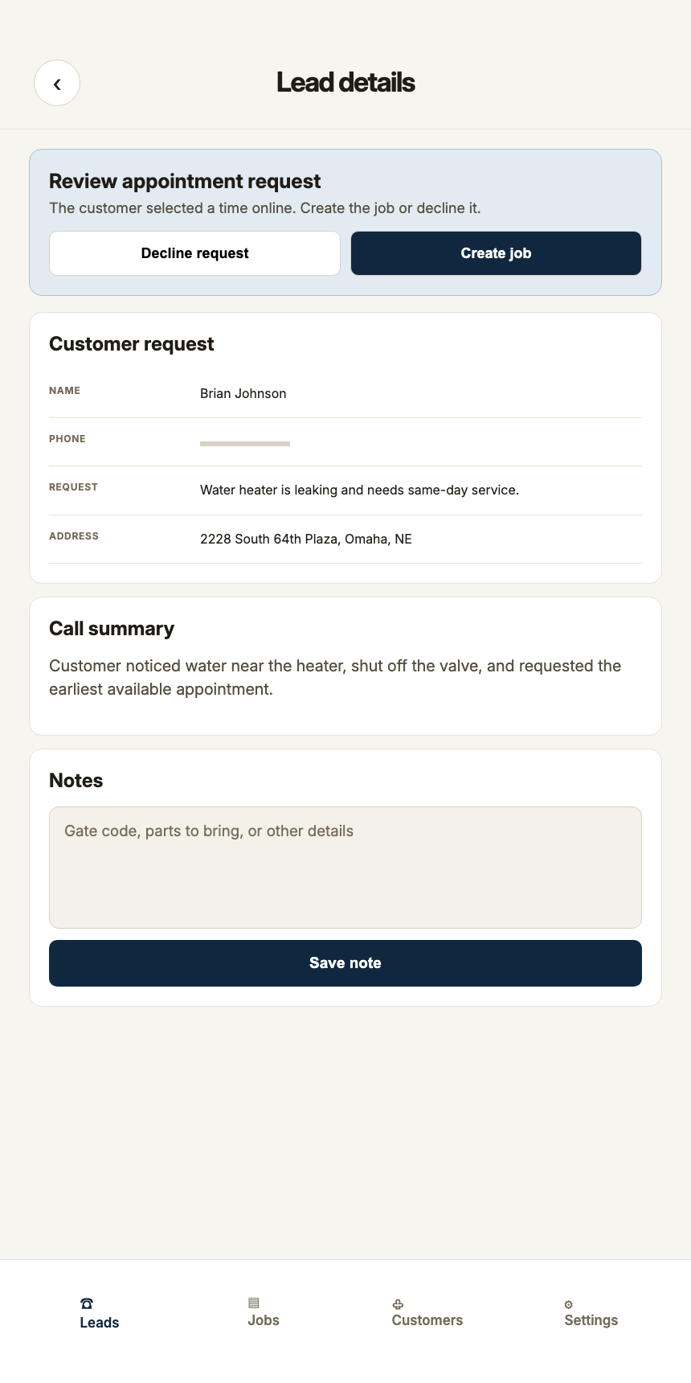
Sample lead details. Available records depend on the call and provider.

Understand what the caller needs
Review the request, caller information, notes and booking status. Recordings and transcripts appear when available. Decide whether to contact the caller, save a customer or schedule a job.
A useful question for your demo: Which details should the receptionist collect for our services?

3 Keep the schedule organized
  - Booking follows the availability saved in Handled Calls
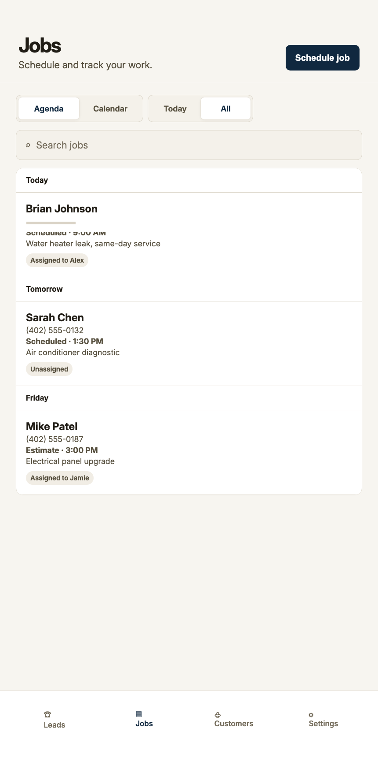
Sample job agenda. Select Calendar to change the view or Schedule job to add work.

Choose the booking approach
With instant voice booking enabled, the receptionist can check saved availability and create a job after the caller accepts an eligible time. Otherwise, the request waits for your team. Website appointment requests require owner approval.
The app uses its own schedule; Google Calendar, Outlook and other external calendar sync are not currently supported.
See this with the team: handledcalls.com/book-a-demo/

